**DEVEPOS**

DAY 4 Task

**Pod**

1. Create a pod using run command

$ kubectl run <pod-name> --image=<image-name> --port=<container-port>

$ kubectl run my-pod --image=nginx --port=80

2. View all the pods

(In default namespace)

$ kubectl get pods

(In All namespace)

$ kubectl get pods -A

# For a specific namespace

$ kubectl get pods -n kube-system

# For a specific type

$ kubectl get pods <pod-name>

$ kubectl get pods <pod-name> -o wide

$ kubectl get pods <pod-name> -o yaml

$ kubectl get pods <pod-name> -o json

3. Describe a pod (View Pod details)

$ kubectl describe pod <pod-name>

$ kubectl describe pod my-pod

4. View Logs of a pod

$ kubectl logs <pod-name>

$ kubectl logs my-pod

5. Execute any command inside Pod (Inside Pod OS)

$ kubectl exec <pod-name> -- <command>

apiVersion: v1

kind: Pod

metadata:

name: my-pod

labels:

app: my-web-app

type: backend

spec:

containers:

- name: nginx-container

image: nginx

ports:

- containerPort: 80

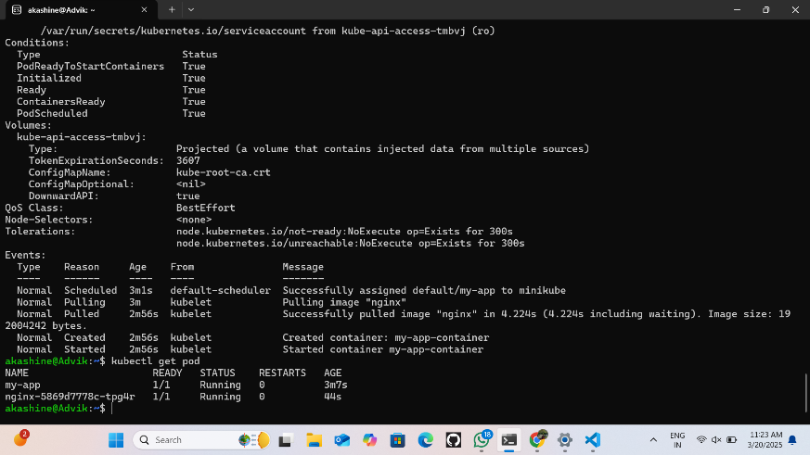

**Replica**

1. Create ReplicaSet by executing above YAML file

$ kubectl create -f rs-test.yml

# Do necessary modifications if exist, else create new

$ kubectl apply -f rs-test.yml

# Completely Modify Pod Template

$ kubectl replace –f rs-test.yml

2. View ReplicaSets

$ kubectl get replicasets

$ kubectl get rs

$ kubectl get rs –o wide

$ kubectl get rs <replica-set-name> –o json

$ kubectl get rs <replica-set-name> –o yaml

3. View ReplicaSet Description

$ kubectl describe rs <replica-set-name>

4. We can modify generated/updated YAML file

$ kubectl edit rs <replica-set-name>

## change replicas: count to any other value then (ESC):wq

# We can modify our YAML file and then execute apply command

$ kubectl apply -f rs-test.yml

## We can Even scale using command also

$ kubectl scale replicaset <replicaset-name> --replicas=<desired-replica-count>

5. Delete ReplicaSet

$ kubectl delete rs <replica-set-name>

$ kubectl delete -f rs-test.yml

apiVersion: apps/v1

kind: Deployment

metadata:

name: my-deploy

labels:

name: my-deploy

spec:

replicas: 3

selector:

matchLabels:

apptype: web-backend

strategy:

type: RollingUpdate

template:

metadata:

labels:

apptype: web-backend

spec:

containers:

- name: my-app

image: nginx

ports:

- containerPort: 7070

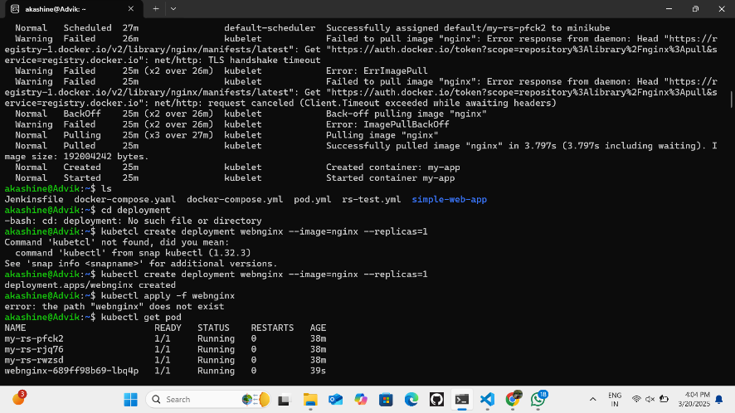

**Deploy**

1. Create Deployment by executing above YAML file

$ kubectl create -f web-deploy.yml

# Do necessary modifications if exist, else create new

$ kubectl create -f web-deploy.yml

# Completely Modify Pod Template

$ kubectl replace –f web-deploy.yml

#Create deploy

kubectl create deployment webnginx2 --image=nginx:latest --replicas=1

2. View Deployments

$ kubectl get deployments

$ kubectl get deploy

$ kubectl get deploy -o wide

$ kubectl get deploy <deployment-name> -o json

$ kubectl get deploy <deployment-name> -o yaml

3. View Deployment Description

$ kubectl describe deploy <deployment-name>

4. We can modify generated/updated YAML file

$ kubectl edit deploy <deployment-name>

## change replicas: count to any other value then (ESC):wq

# We can modify our YAML file and then execute apply command

$ kubectl apply -f web-deploy.yml

## We can Even scale using command also

$ kubectl scale deploy <deployment-name> --replicas=<desired-replica-count>

5. Delete Deployment

$ kubectl delete deploy <deployment-name>

$ kubectl delete -f web-deploy.yml

apiVersion: apps/v1

kind: Deployment

metadata:

name: my-deploy

labels:

name: my-deploy

spec:

replicas: 1

selector:

matchLabels:

apptype: web-backend

strategy:

type: RollingUpdate

template:

metadata:

labels:

apptype: web-backend

spec:

containers:

- name: my-app

image:

ports:

- containerPort: 7070

---

apiVersion: v1

kind: Service

metadata:

name: my-service

labels:

app: my-service

type: backend-app

spec:

type: NodePort

ports:

- targetPort: 7070

port: 7070

nodePort: 30002

selector:

apptype: web-backend

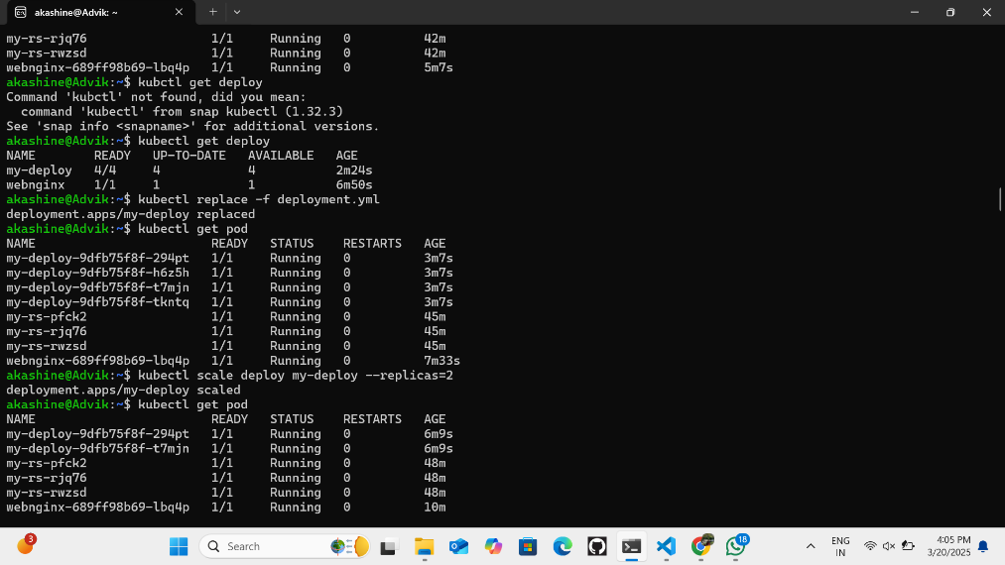

**Minikube Service**

Minikube service

#need to create a yml file

sudo nano deployment.yml

apiVersion: apps/v1

kind: Deployment

metadata:

name: my-deploy

labels:

name: my-deploy

spec:

replicas: 1

selector:

matchLabels:

apptype: web-backend

strategy:

type: RollingUpdate

template:

metadata:

labels:

apptype: web-backend

spec:

containers:

- name: my-app

image:

ports:

- containerPort: 9000

---

apiVersion: v1

kind: Service

metadata:

name: my-service

labels:

app: my-service

spec:

type: NodePort

ports:

- port: 9000

targetPort: 8080

nodePort: 30002

selector:

apptype: web-backend

#Apply the deployment

kubectl apply -f deployment.yml

#replace the deployment

kubectl replace -f deployment.yml

#Run the service

minikube service my-service

#curl the url

curl <url>/<file_name>/

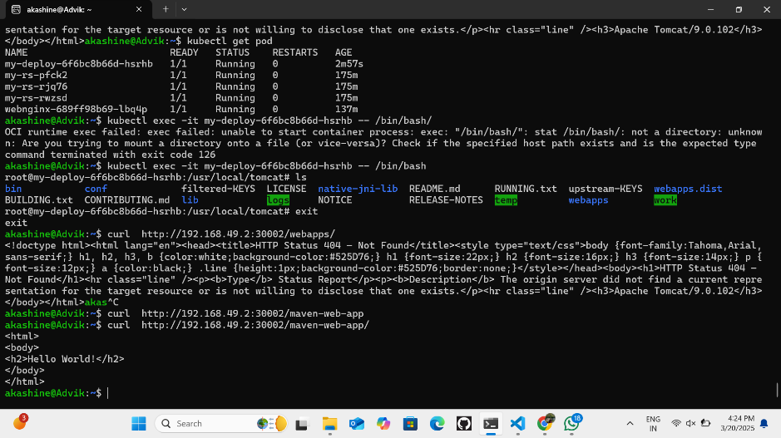

**Namespace**

# To create a namespace:

$ kubectl create namespace <namespace-name>

$ kubectl create ns my-bank

# To switch to a specific namespace: (make this as default type)

$ kubectl config set-context --current --namespace=<namespace-name>

# To list all namespaces:

$ kubectl get namespaces

# To get resources within a specific namespace:

$ kubectl get <resource-type> -n <namespace-name>

$ kubectl get deploy -n my-bank

$ kubectl get deploy --namespace my-bank

$ kubectl get all --namespace my-bank

# To delete a namespace and all associated resources:

$ kubectl delete namespace <namespace-name>

$ kubectl delete ns my-bank

kubectl create ns my-deploy

kubectl apply -f deploy.yml -n mydeploy

apiVersion: v1

kind: Namespace

metadata:

name: my-demo-ns

apiVersion: v1

kind: Pod

metadata:

name: my-pod

namespace: my-demo-ns

spec:

containers:

- name: my-container

image: nginx:latest

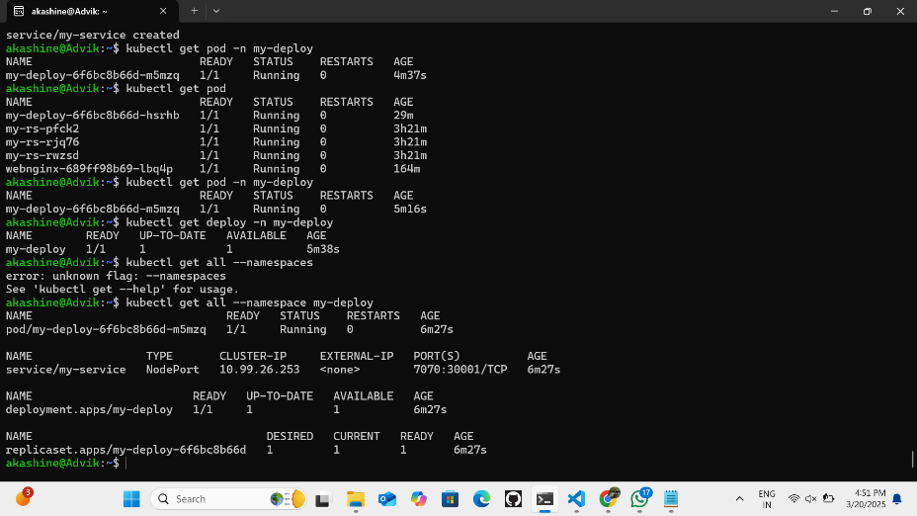Namespace

Namespace yml

